1. Desarrollo de reconocimiento de las alteraciones

Escriba el nombre de las siguientes alteraciones

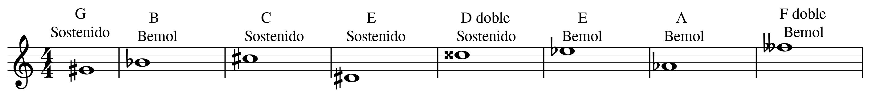

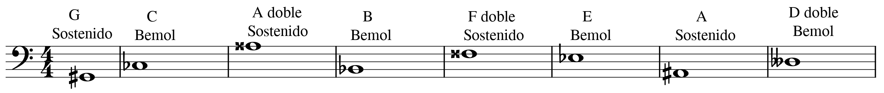

Escriba en el pentagrama las siguientes alteraciones

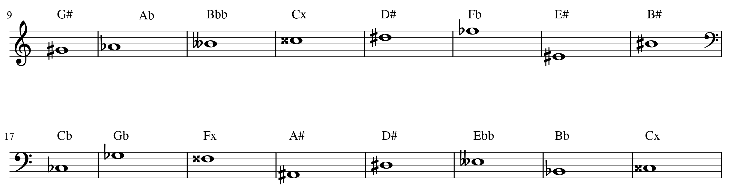

2. Construir una escala cromática (ascendente y descendente) a

partir de un sonido base.

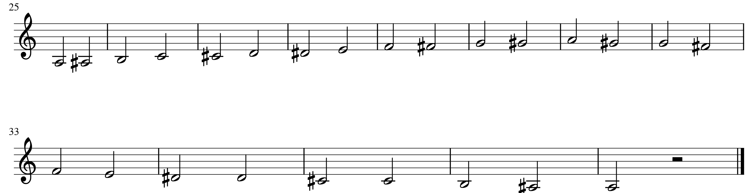

1. Completar el siguiente cuadro de intervalos

|  |  |  |  |  |  |
| --- | --- | --- | --- | --- | --- |
| C | Mayor | Menor | Justo | Disminuido | Aumentado |
| 2 | 1T. D | ½ T. Db | NO | 0T. Dbb | 1 ½ T. D# |
| 3 | 2T. E | 1 ½ T. Eb | NO | 1T. Ebb | 2 ½ T. E# |
| 4 | NO | NO | 2 ½ T. F | 2T. Fb | 3T. F# |
| 5 | NO | NO | 3 ½ T. G | 3T. Gb | 4T. G# |
| 6 | 4 ½ T. A | 4T. Ab | NO | 3 ½ T. Abb | 5T. A# |
| 7 | 5 ½ T. B | 5T. Bb | NO | 4 ½ T. Bbb | 6T. B# |
| 8 | NO | NO | 6T. C | 5 ½ T. Cb | 6 ½ T. C# |

1. Identifique los siguientes intervalos:
2. Complete las siguientes matrices de intervalos

|  |  |  |  |  |  |
| --- | --- | --- | --- | --- | --- |
| Nota inicial | 4 justa | 6 menor | 2 menor | 7 mayor | 3 mayor |
| C | F | Ab | Db | B | E |
| Nota inicial | 5 justa | 6 mayor | 2 mayor | Unísono | 3 menor |
| F | C | D | G | F | Ab |
| Nota inicial | 2 mayor | 3 menor | 3 mayor | 5 justa | 7 menor |
| G | A | Bb | B | D | F |
| Nota inicial | 4 aumentada | 5 disminuida | 3 mayor | 3 menor | 2 mayor |
| A# | Dx | E | Cx | C# | B# |
| Nota inicial | 4 justa | 6 menor | 2 menor | 7 mayor | 3 mayor |
| Bb | Eb | Gb | Cb | A | D |
| Nota inicial | 2 mayor | 3 menor | 3 mayor | 5 justa | 7 menor |
| Eb | F | Gb | G | Bb | Db |
| Nota inicial | 2 mayor | 3 menor | 3 mayor | 5 justa | 7 mayor |
| E | Fx | G | G# | B | D# |
| Nota inicial | 2 mayor | 3 menor | 3 mayor | 5 justa | 7 menor |
| D | E | F | F# | A | C |

|  |  |
| --- | --- |
| Intervalo | ¿Qué tipo de intervalo es? |
| C – Eb | 3 menor |
| Fb – C# | 5 súper aumentada |
| C – G# | 5 aumentada |
| Ab – G# | Octava justa |
| D – F# | 3 mayor |
| F# - D | 6 menor |
| Bb – Db | 3 menor |
| Gbb – A | 2 súper aumentada |
| C# - D | 2 menor |
| Dx – G# | 4 disminuida |
| C – Bb | 7 menor |
| C – B | 7 mayor |

1. Teniendo en cuenta lo expuesto en el método, respecto a Acordes, se busca entender la construcción de acordes tríadicos con las siguientes cualidades.

|  |  |  |  |
| --- | --- | --- | --- |
| Acorde | Nota base | Tercera | Quinta |
| D mayor | D | F# | A |
| C mayor | C | E | G |
| Bb mayor | Bb | D | F |
| C menor | C | Eb | G |
| F menor | F | Ab | C |
| D menor | D | F | A |
| B disminuido | B | D | F |
| C# mayor | C# | E# | G# |